Test evidences
Ran LocalDevDependencies :
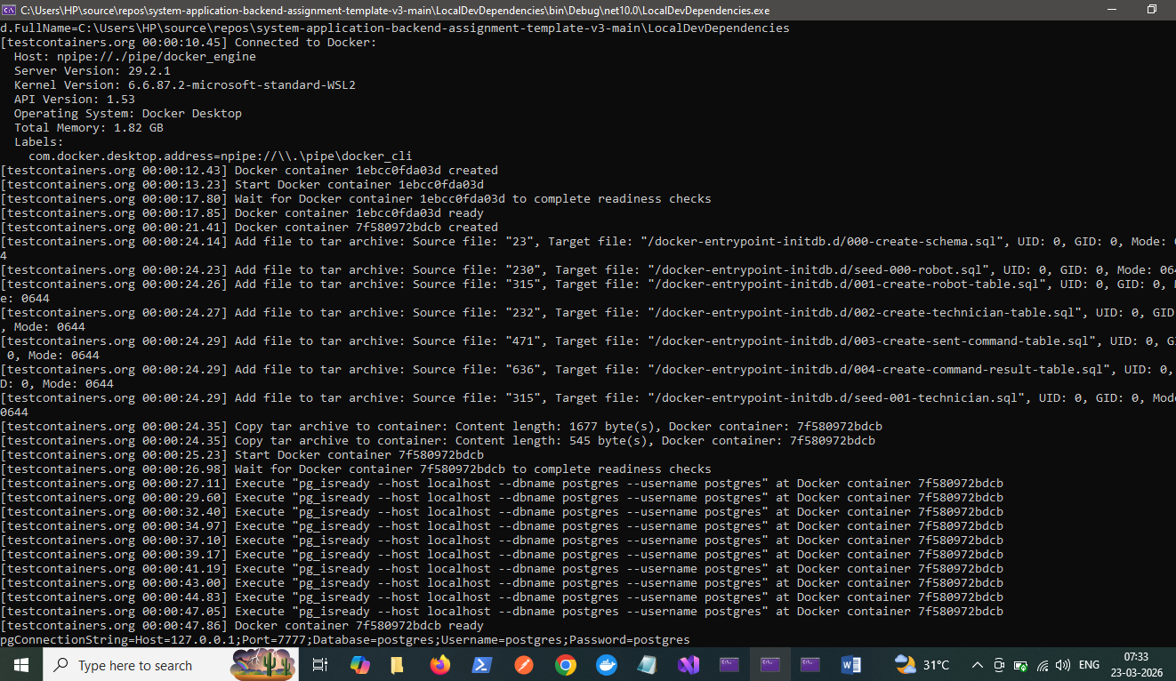
com.docker.desktop.address=npipe://\\.\pipe\docker_cli
[testcontainers.org 00:00:12.43] Docker container 1ebcc0fda03d created
[testcontainers.org 00:00:13.23] Start Docker container 1ebcc0fda03d
[testcontainers.org 00:00:17.80] Wait for Docker container 1ebcc0fda03d to complete readiness checks
[testcontainers.org 00:00:17.85] Docker container 1ebcc0fda03d ready
[testcontainers.org 00:00:21.41] Docker container 7f580972bdcb created
[testcontainers.org 00:00:24.14] Add file to tar archive: Source file: "23", Target file: "/docker-entrypoint-initdb.d/000-create-schema.sql", UID: 0, GID: 0, Mode: 0644
[testcontainers.org 00:00:24.23] Add file to tar archive: Source file: "230", Target file: "/docker-entrypoint-initdb.d/seed-000-robot.sql", UID: 0, GID: 0, Mode: 0644
[testcontainers.org 00:00:24.26] Add file to tar archive: Source file: "315", Target file: "/docker-entrypoint-initdb.d/001-create-robot-table.sql", UID: 0, GID: 0, Mode: 0644
[testcontainers.org 00:00:24.27] Add file to tar archive: Source file: "232", Target file: "/docker-entrypoint-initdb.d/002-create-technician-table.sql", UID: 0, GID: 0, Mode: 0644
[testcontainers.org 00:00:24.29] Add file to tar archive: Source file: "471", Target file: "/docker-entrypoint-initdb.d/003-create-sent-command-table.sql", UID: 0, GID: 0, Mode: 0644
[testcontainers.org 00:00:24.29] Add file to tar archive: Source file: "636", Target file: "/docker-entrypoint-initdb.d/004-create-command-result-table.sql", UID: 0, GID: 0, Mode: 0644
[testcontainers.org 00:00:24.29] Add file to tar archive: Source file: "315", Target file: "/docker-entrypoint-initdb.d/seed-001-technician.sql", UID: 0, GID: 0, Mode: 0644
[testcontainers.org 00:00:24.35] Copy tar archive to container: Content length: 1677 byte(s), Docker container: 7f580972bdcb
[testcontainers.org 00:00:24.35] Copy tar archive to container: Content length: 545 byte(s), Docker container: 7f580972bdcb
[testcontainers.org 00:00:25.23] Start Docker container 7f580972bdcb
[testcontainers.org 00:00:26.98] Wait for Docker container 7f580972bdcb to complete readiness checks
[testcontainers.org 00:00:27.11] Execute "pg_isready --host localhost --dbname postgres --username postgres" at Docker container 7f580972bdcb
[testcontainers.org 00:00:29.60] Execute "pg_isready --host localhost --dbname postgres --username postgres" at Docker container 7f580972bdcb
[testcontainers.org 00:00:32.40] Execute "pg_isready --host localhost --dbname postgres --username postgres" at Docker container 7f580972bdcb
[testcontainers.org 00:00:34.97] Execute "pg_isready --host localhost --dbname postgres --username postgres" at Docker container 7f580972bdcb
[testcontainers.org 00:00:37.10] Execute "pg_isready --host localhost --dbname postgres --username postgres" at Docker container 7f580972bdcb
[testcontainers.org 00:00:39.17] Execute "pg_isready --host localhost --dbname postgres --username postgres" at Docker container 7f580972bdcb
[testcontainers.org 00:00:41.19] Execute "pg_isready --host localhost --dbname postgres --username postgres" at Docker container 7f580972bdcb
[testcontainers.org 00:00:43.00] Execute "pg_isready --host localhost --dbname postgres --username postgres" at Docker container 7f580972bdcb
[testcontainers.org 00:00:44.83] Execute "pg_isready --host localhost --dbname postgres --username postgres" at Docker container 7f580972bdcb
[testcontainers.org 00:00:47.05] Execute "pg_isready --host localhost --dbname postgres --username postgres" at Docker container 7f580972bdcb
[testcontainers.org 00:00:47.86] Docker container 7f580972bdcb ready
pgConnectionString=Host=127.0.0.1;Port=7777;Database=postgres;Username=postgres;Password=postgres
DB connection ready here……
Then Set Server Project as Start up project
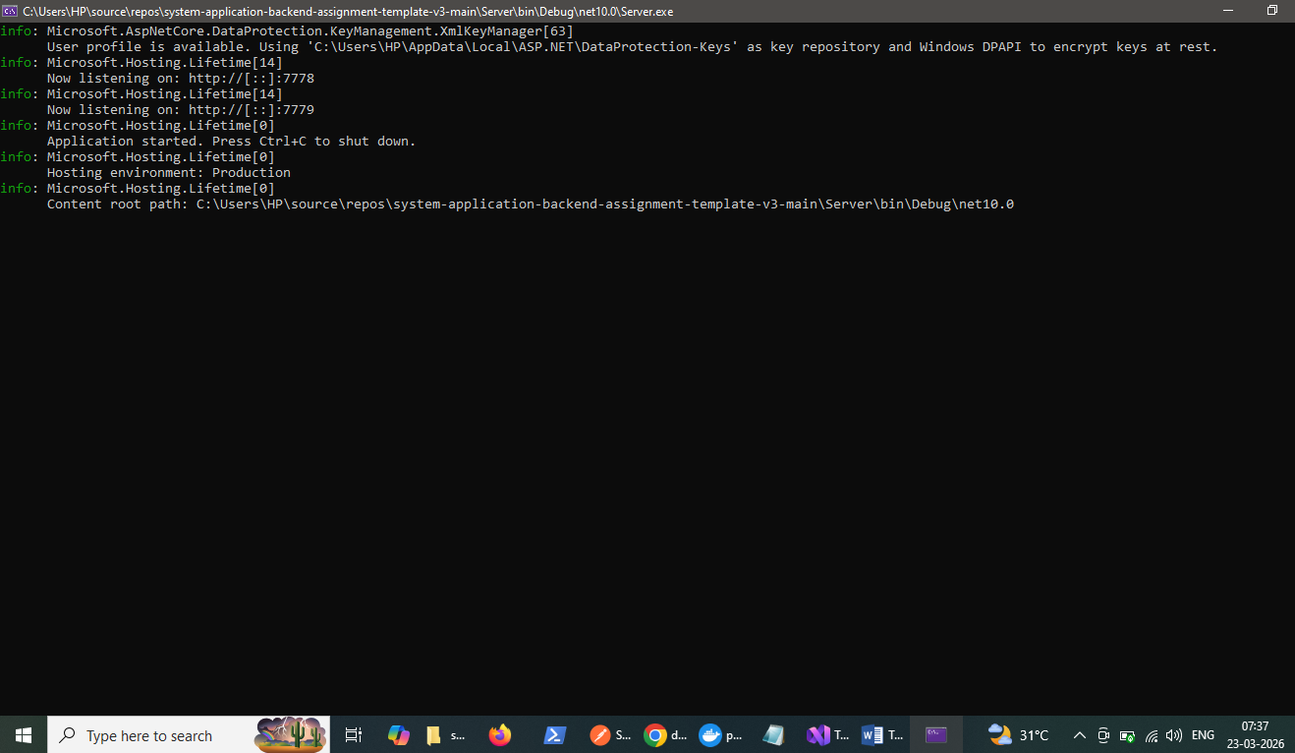
http://localhost:7779/ - Its RestAPI endpoint
http://localhost:7778 – grpc
Swagger Url : http://localhost:7779/Swagger/
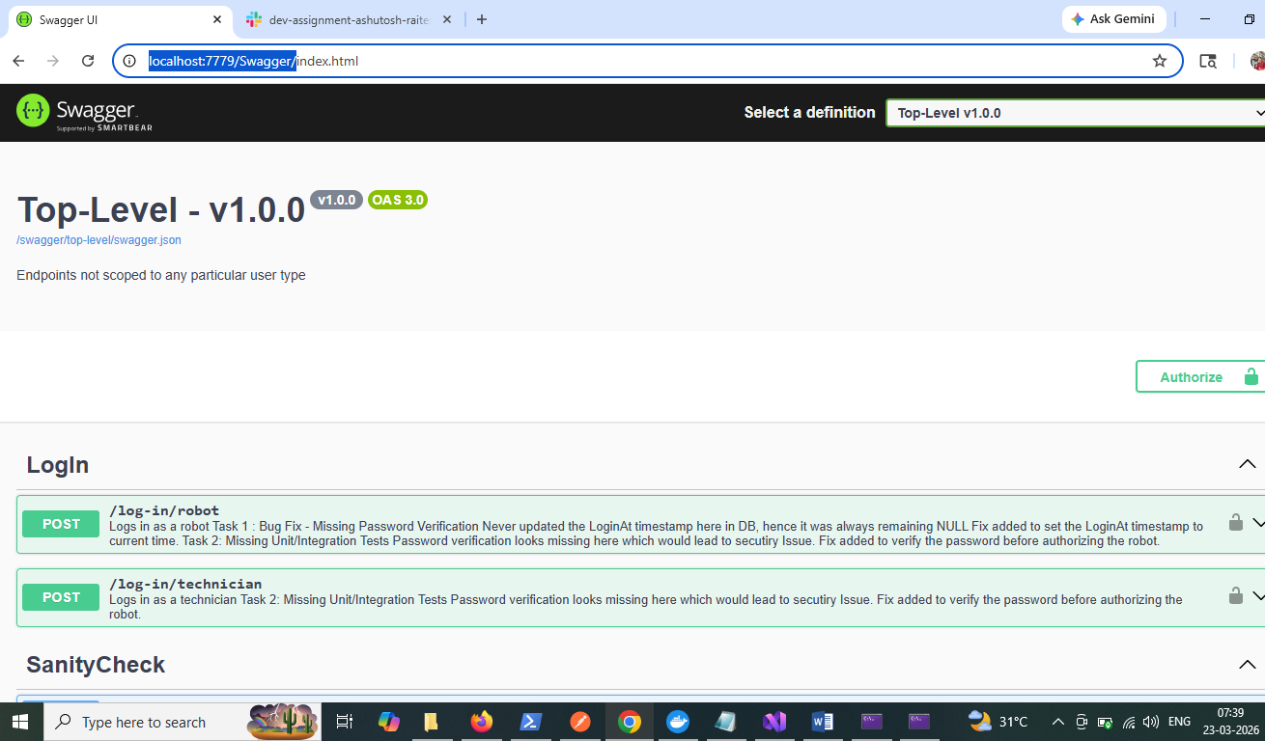

SanityCheck :
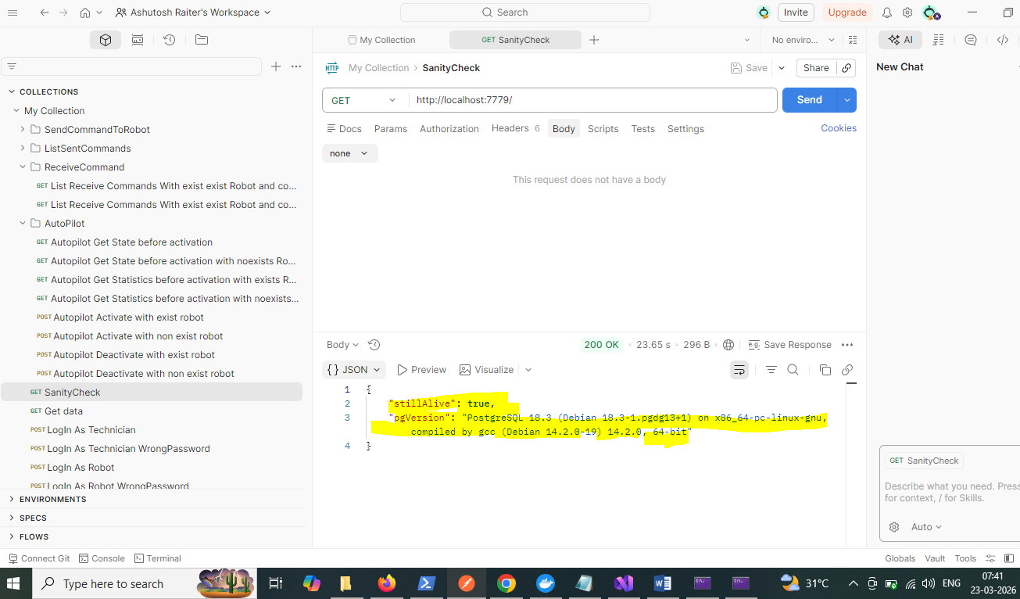

Ran RobotClient
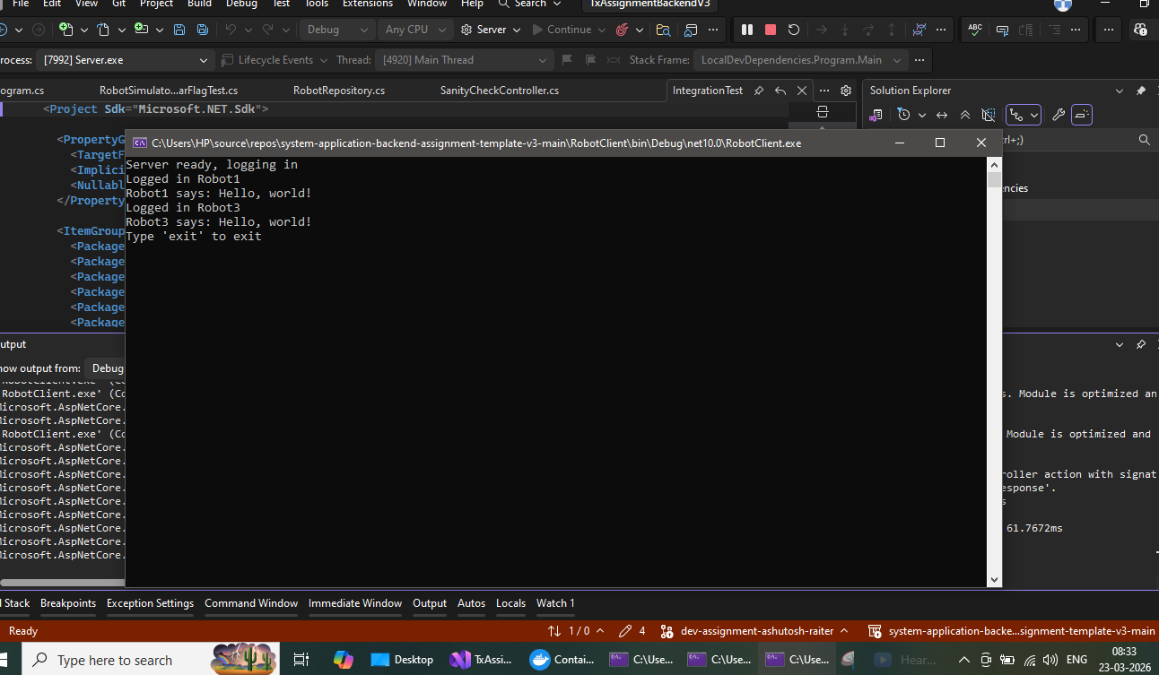

Exec Post -> http://localhost:7779/log-in/technician
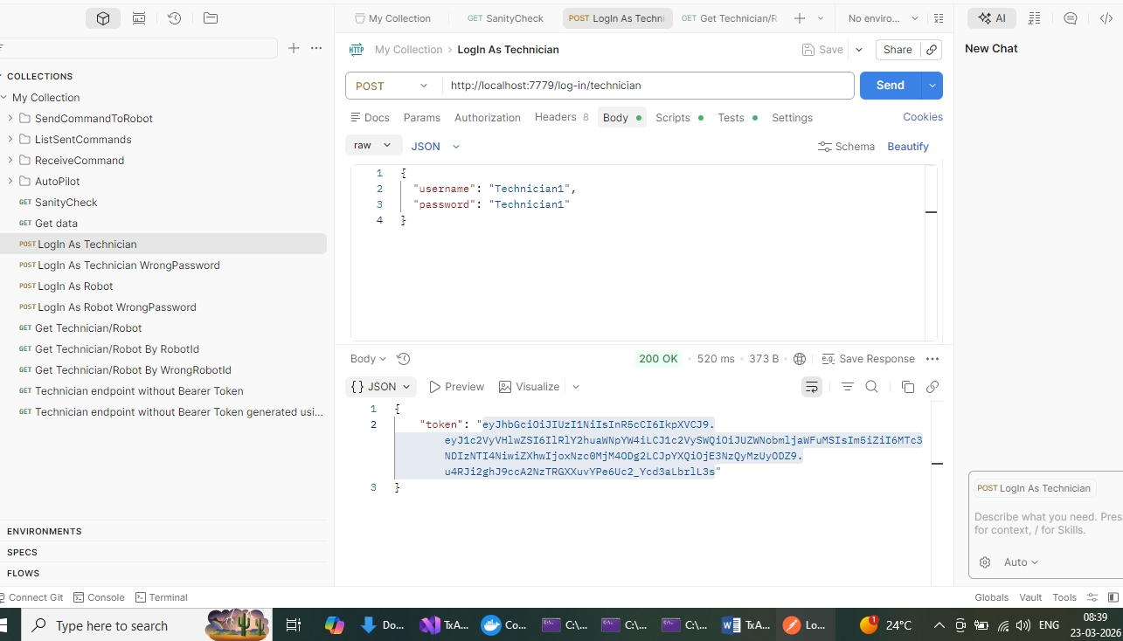
Token generated,copied to Authorization of http://localhost:7779/technician-user/robot

Exec http://localhost:7779/technician-user/robot
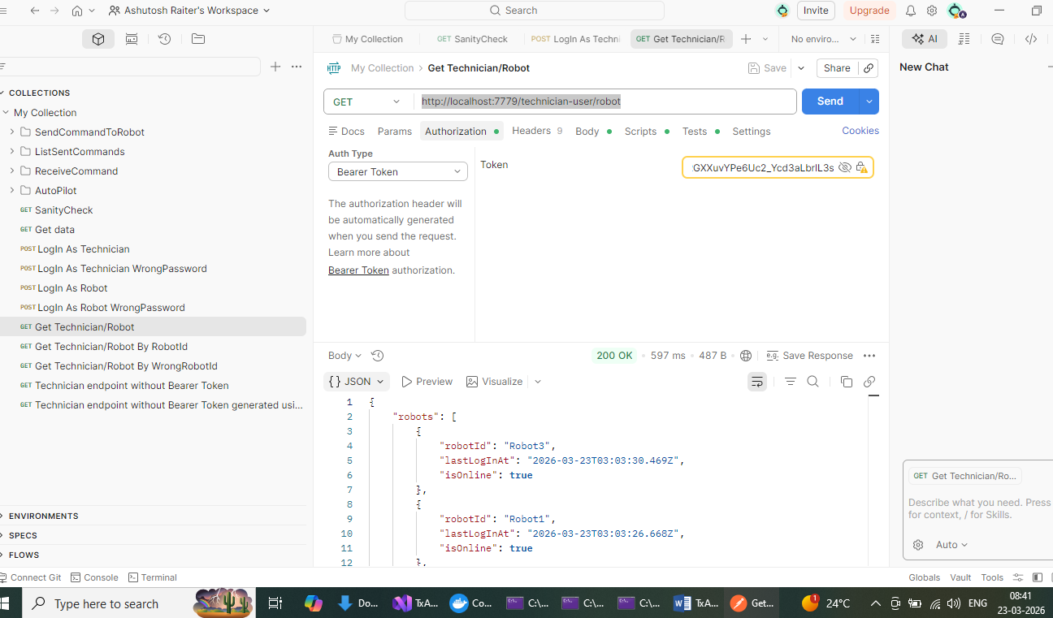
Response says Robo1 and Robo2 are online,since we have RobotClient connected to them.
Exec Post -> http://localhost:7779/technician-user/robot/Robot1/command with ScanEnvironmentCommand
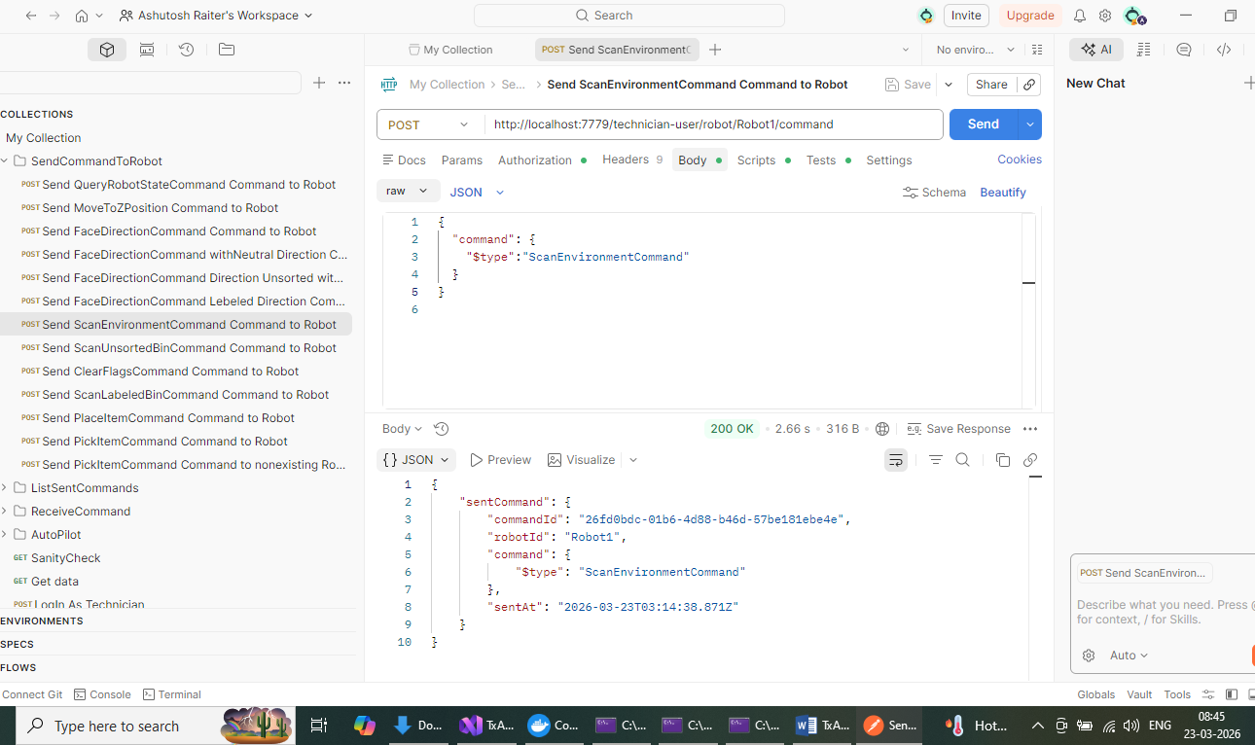
In RobotClient console
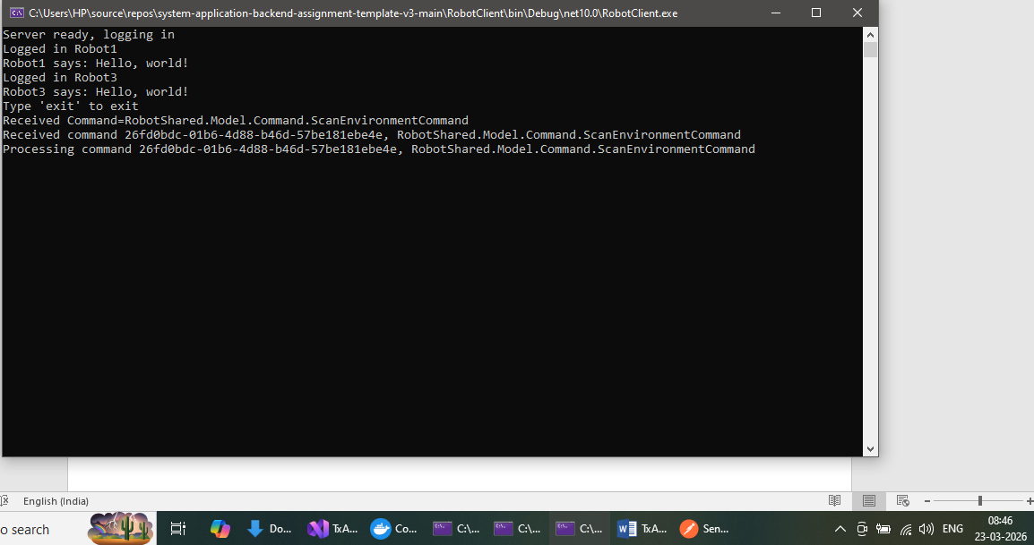

Exec Post -> http://localhost:7779/technician-user/robot/Robot1/command with QueryRobotStateCommand
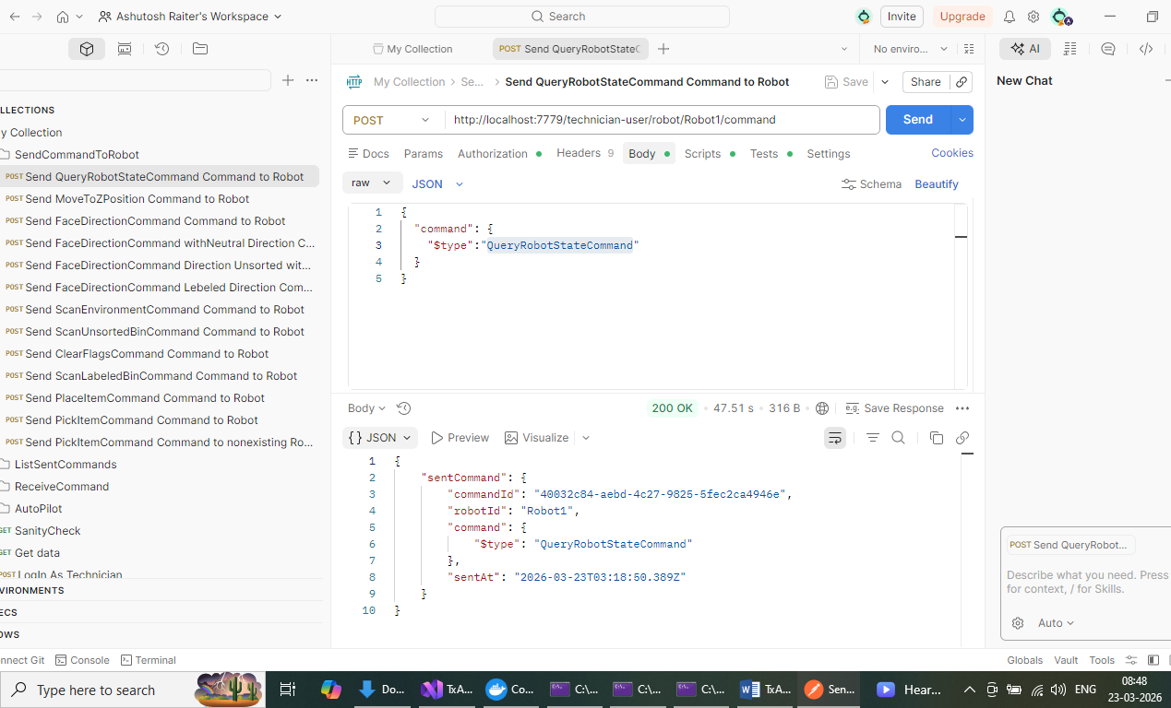
In RobotClient console
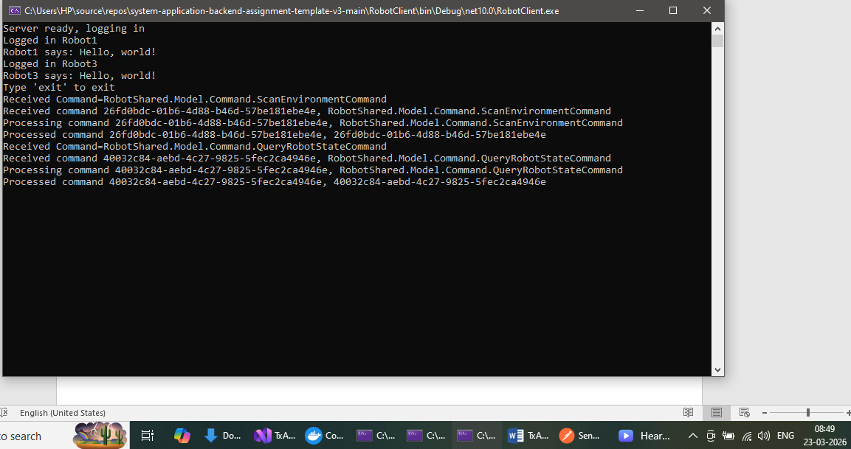
Exec Post -> http://localhost:7779/technician-user/robot/Robot1/command with MoveToZPositionCommand

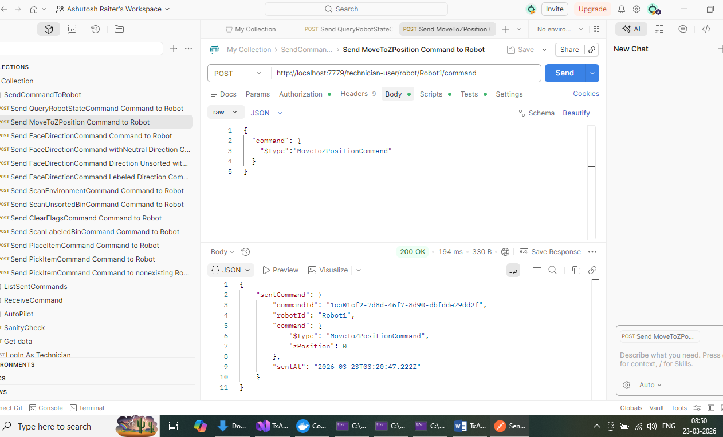
In RobotClient console
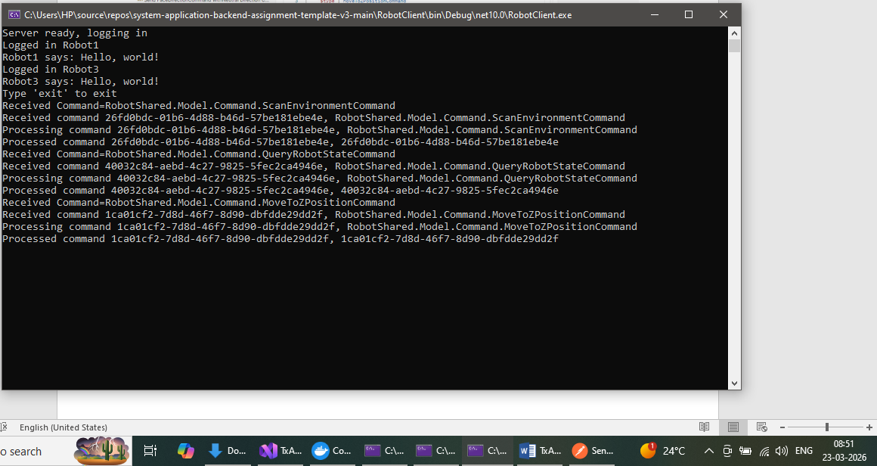
Exec Post -> http://localhost:7779/technician-user/robot/Robot1/command with FaceDirectionCommand
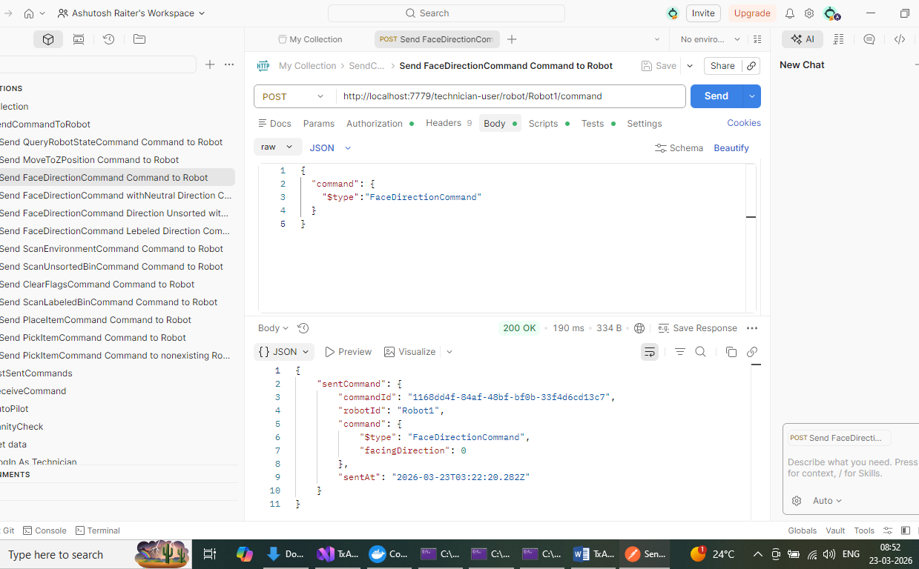

In RobotClient console
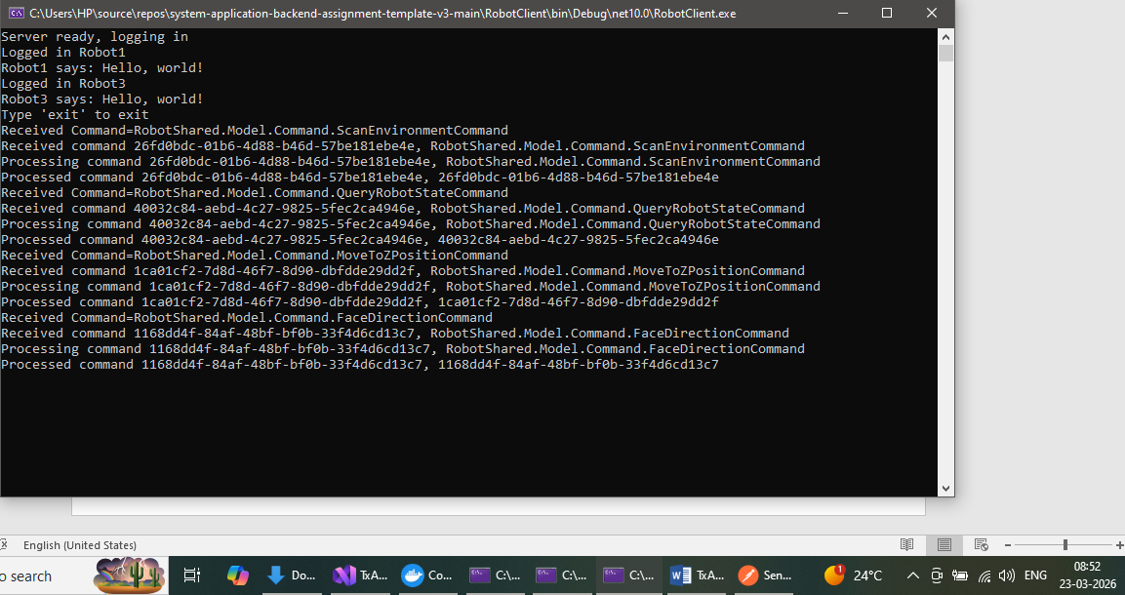
Exec Post -> http://localhost:7779/technician-user/robot/Robot1/command with FaceDirectionCommand with facing direction as UnsortedBin
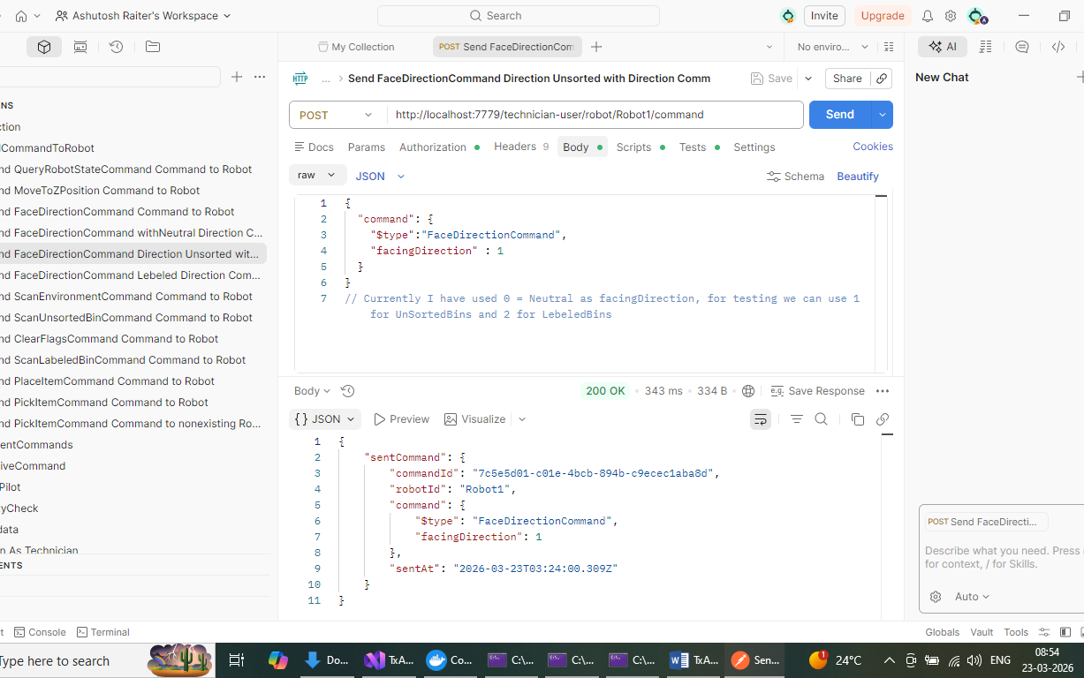
RobotCOnsole
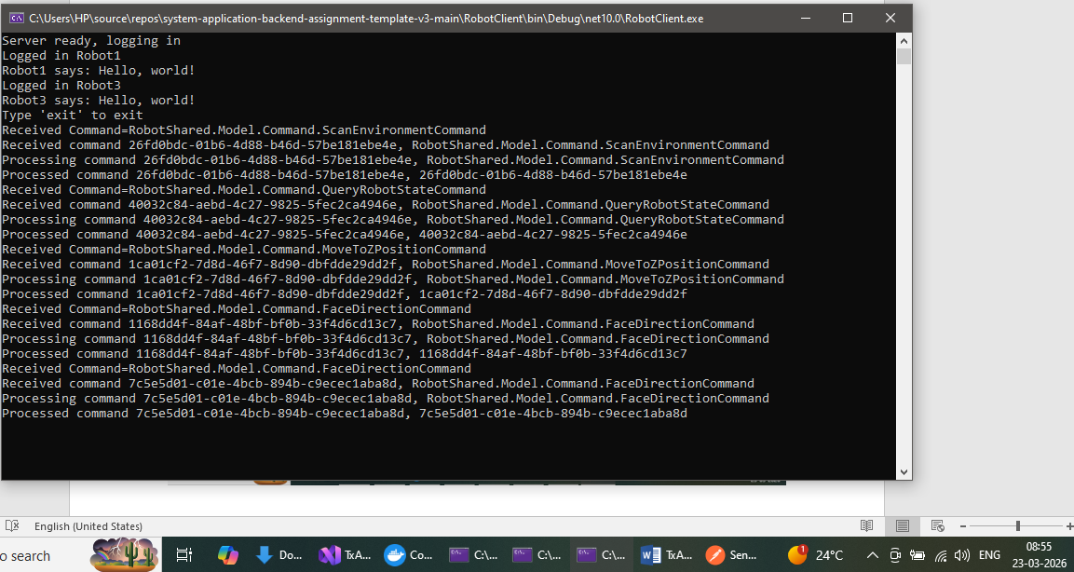
Exec Post -> http://localhost:7779/technician-user/robot/Robot1/command with ScanUnsortedBinCommand
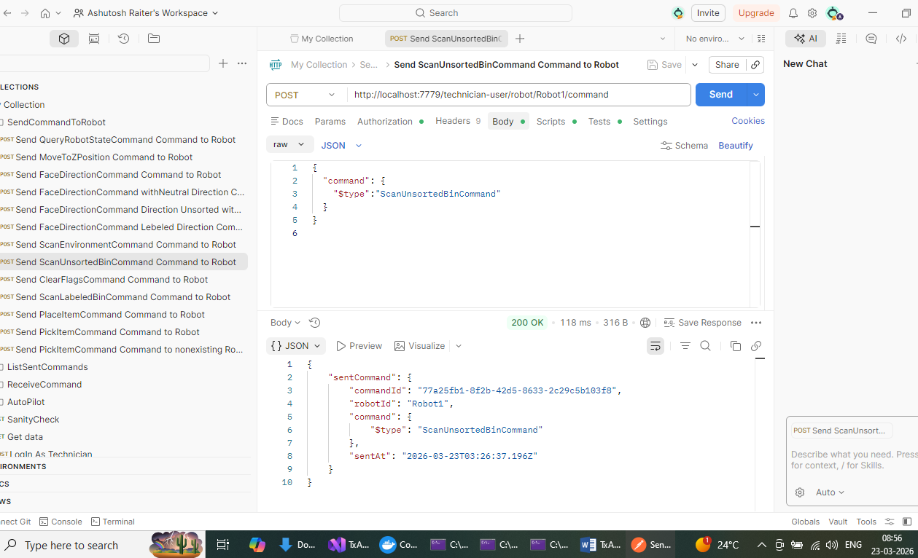
RobotClient Console
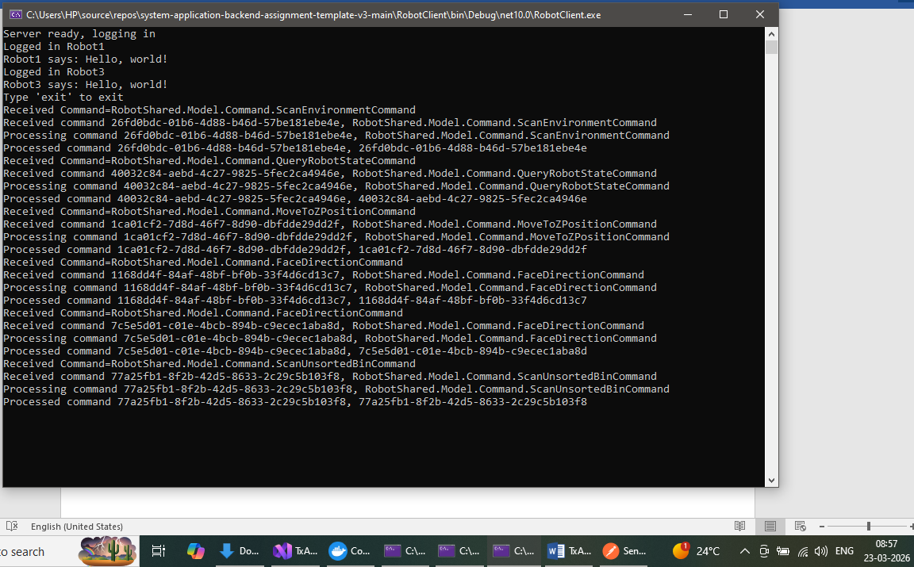
Exec Post -> http://localhost:7779/technician-user/robot/Robot1/command with ScanLabeledBinCommand
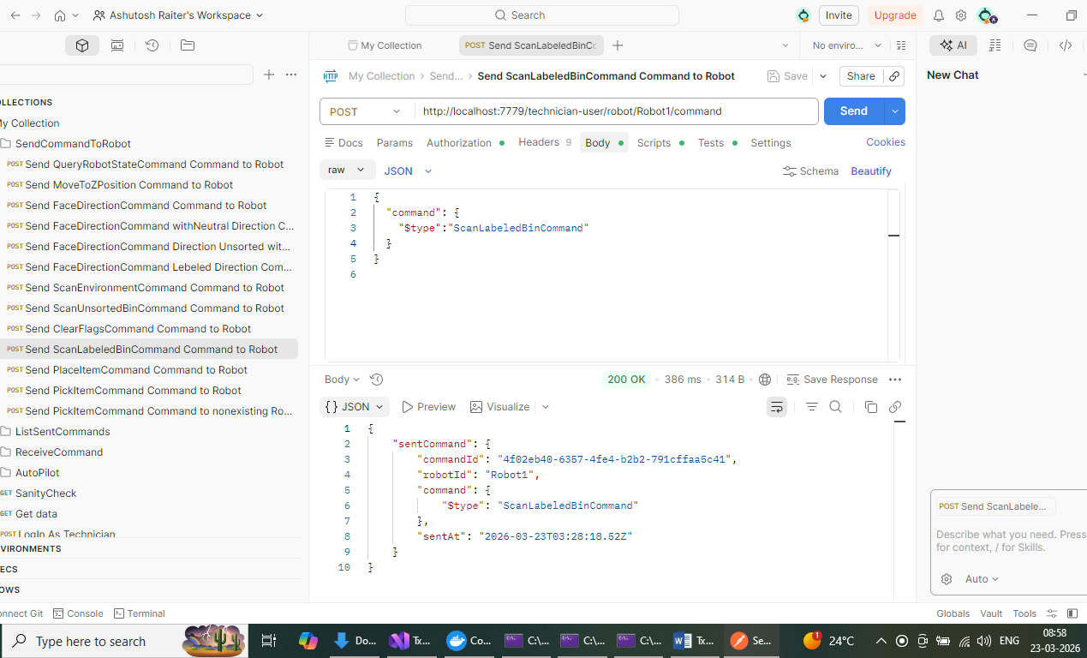

RobotClient Console
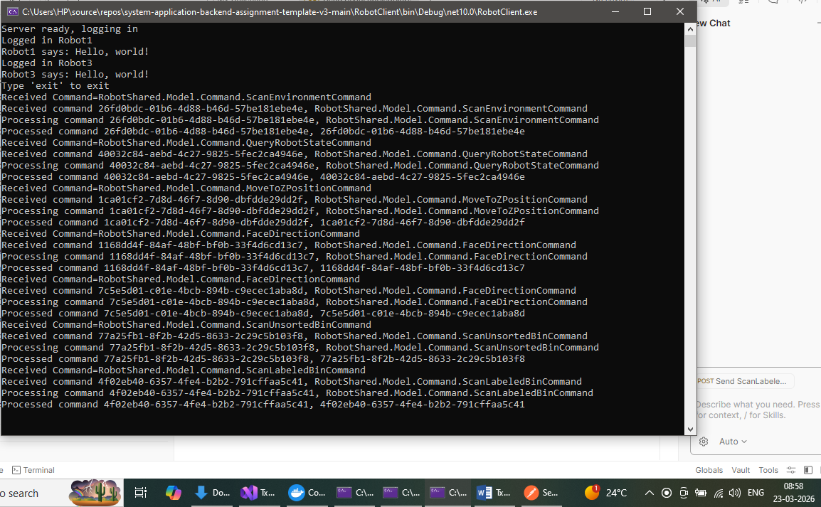
Exec Post -> http://localhost:7779/technician-user/robot/Robot1/command with PickItemCommand
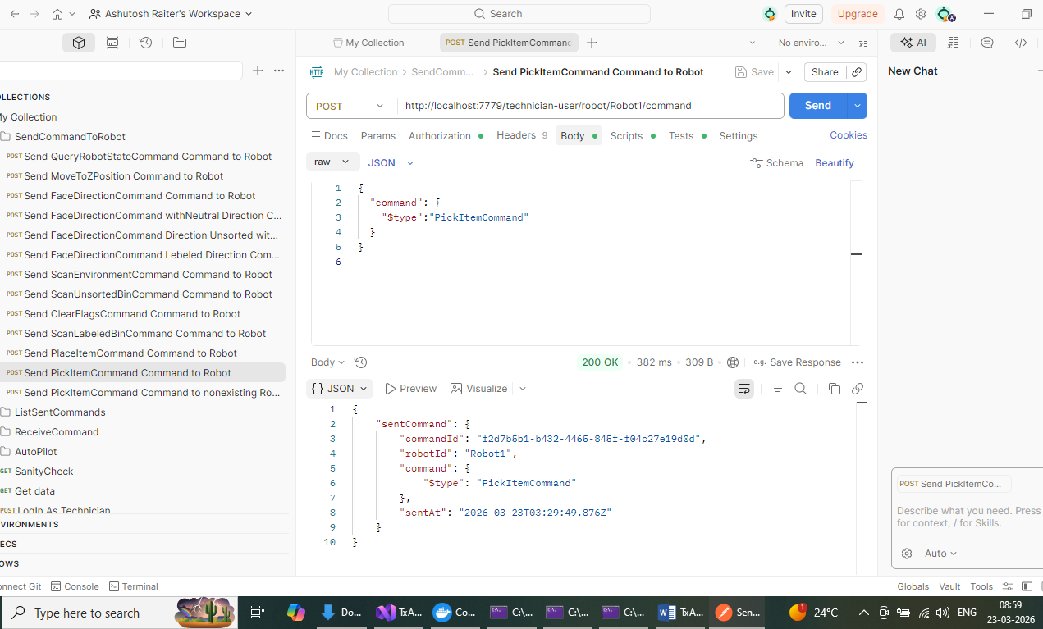
RobotClient Console
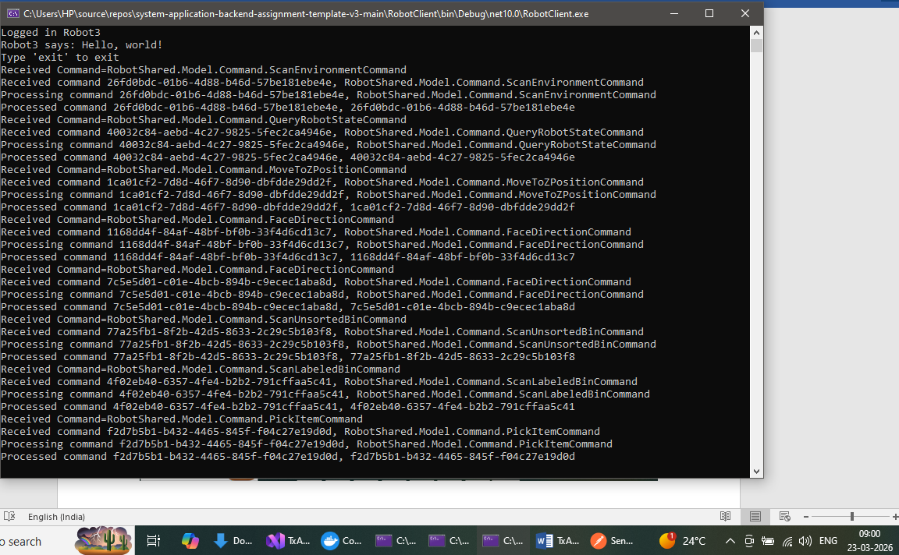

Exec Post -> http://localhost:7779/technician-user/robot/Robot1/command with PlaceItemCommand

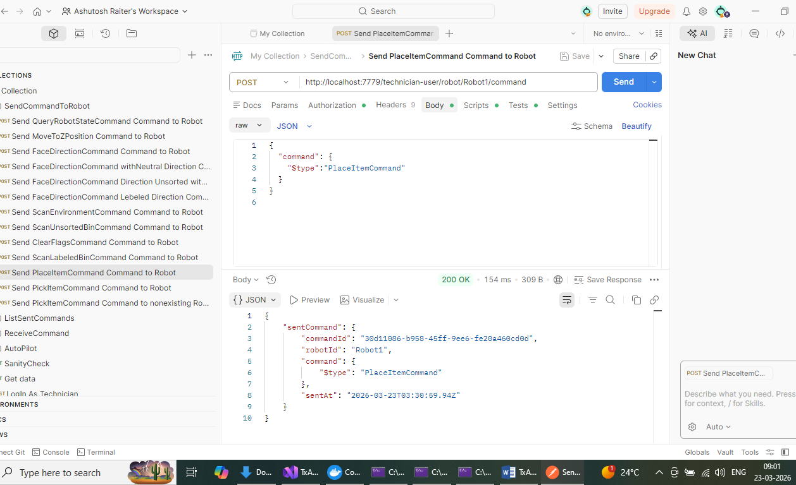
Robot Client Console
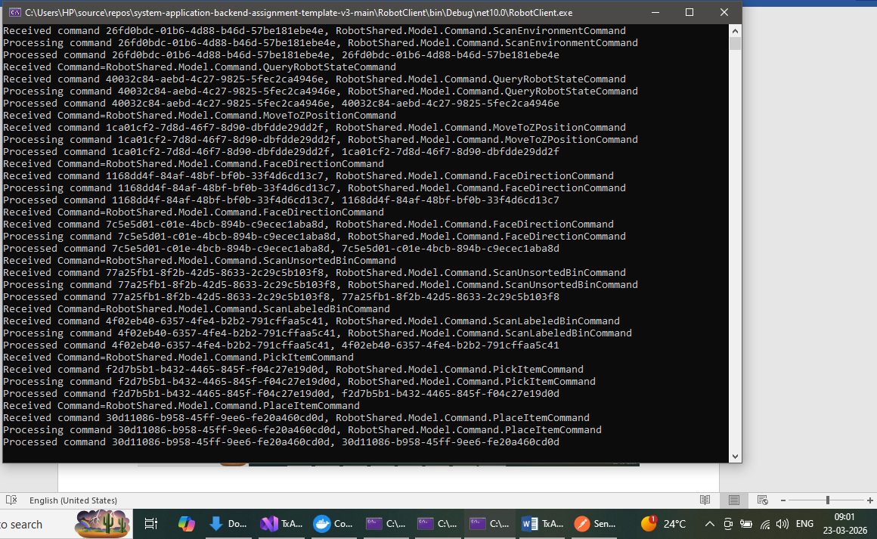
Exec Post -> http://localhost:7779/technician-user/robot/Robot1/command with ClearFlagsCommand
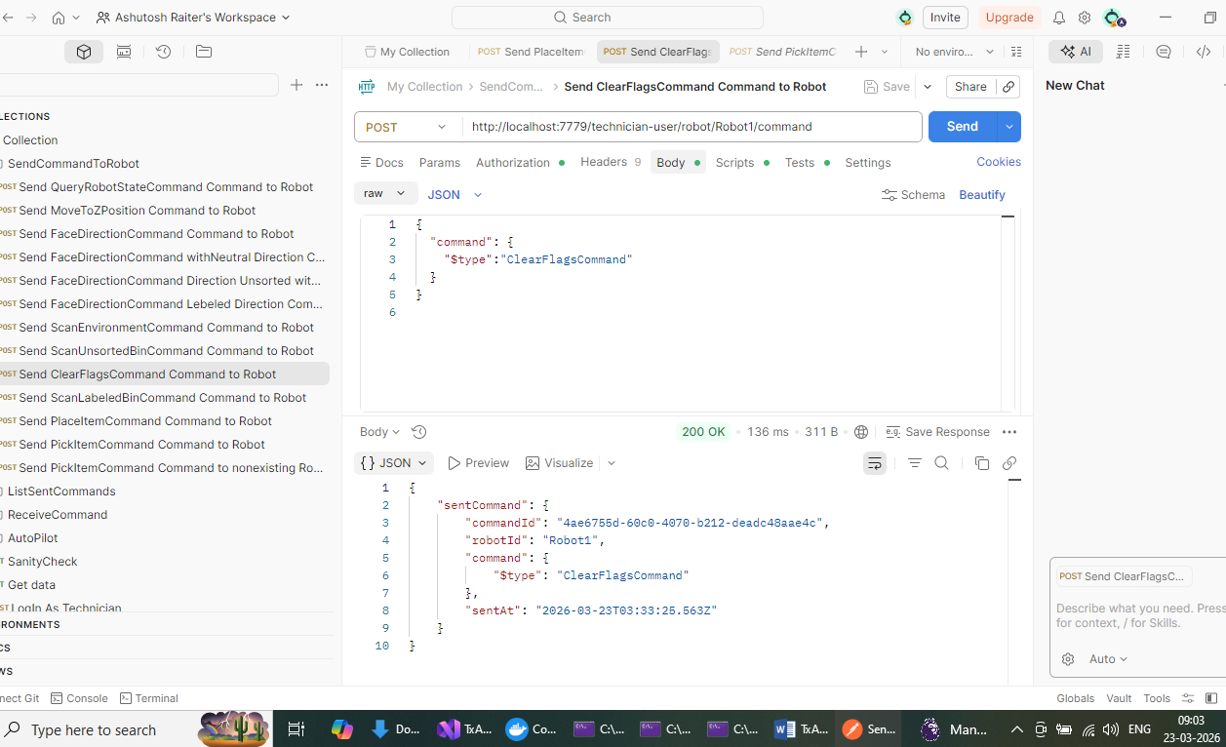
RobotCLient Console
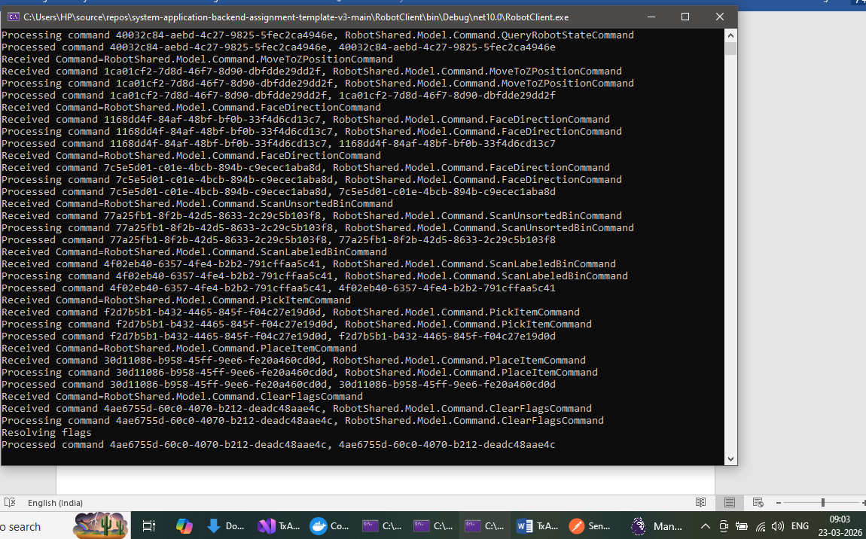
Exec Post -> http://localhost:7779/technician-user/robot/Robot1/command/sent to check commands persisted
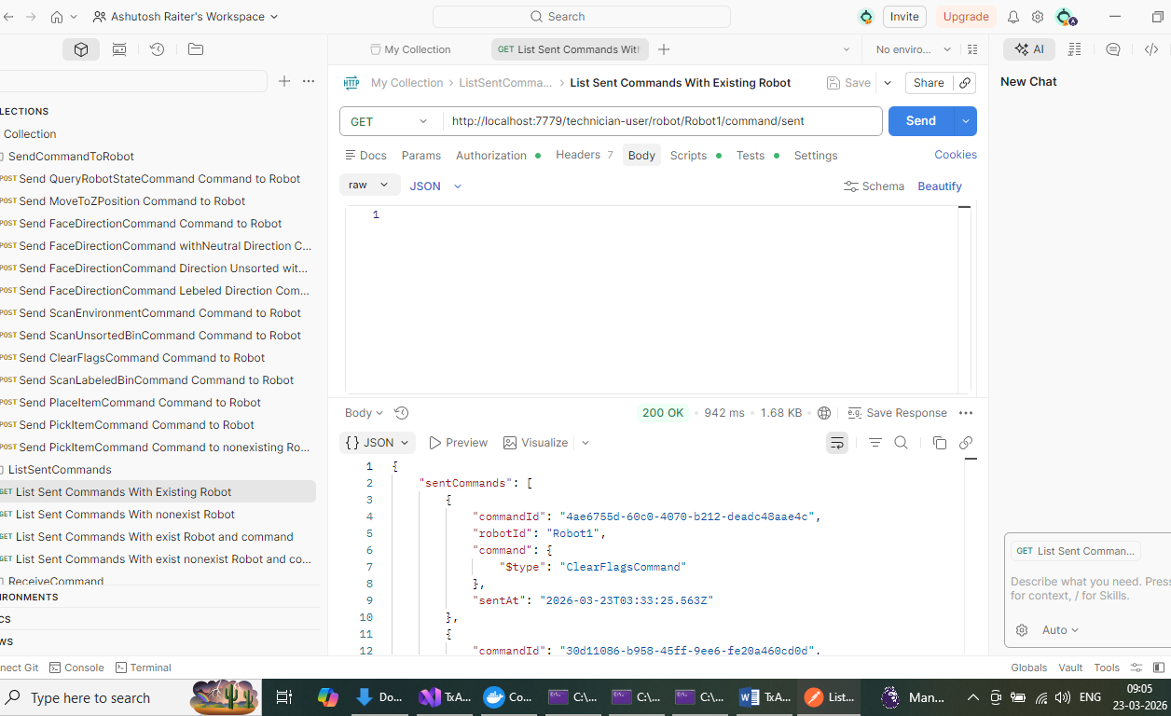
Exec Post -> http://localhost:7779/technician-user/robot/Robot1/command/f2d7b5b1-b432-4465-845f-f04c27e19d0d/sent for one of the commandId
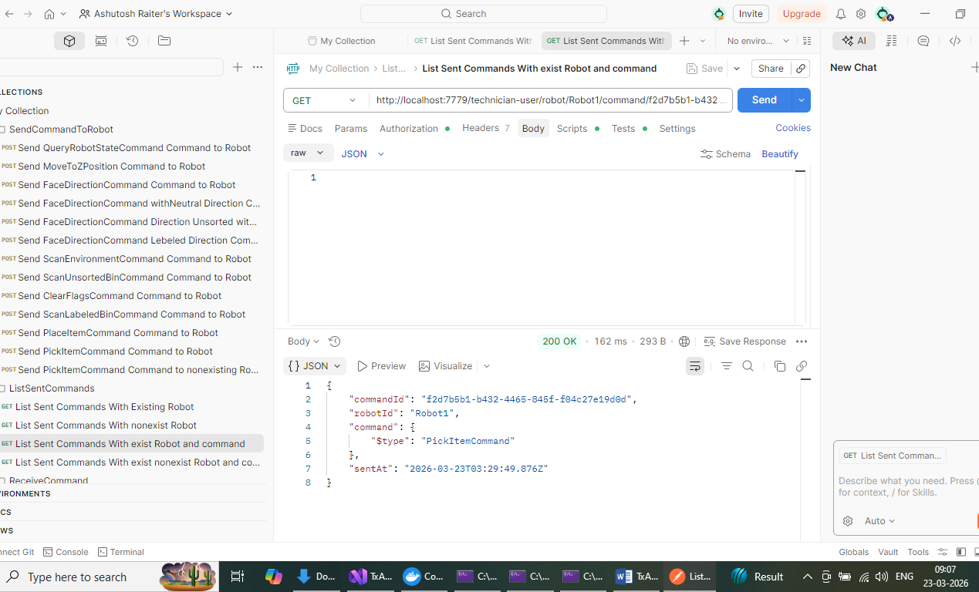

Exec http://localhost:7779/technician-user/robot/Robot1/command/result/received
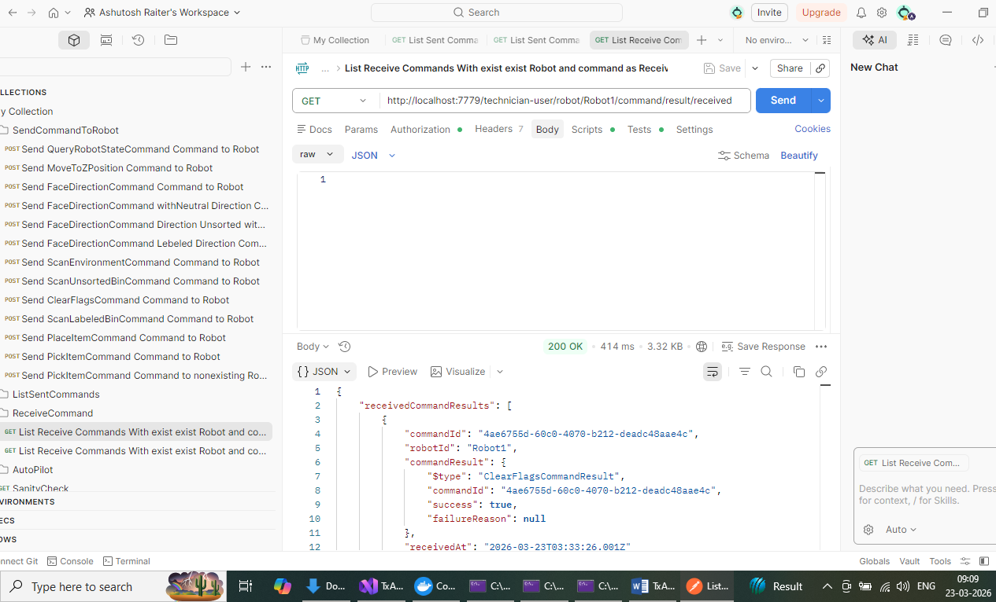
Exec http://localhost:7779/technician-user/robot/Robot1/command/30d11086-b958-45ff-9ee6-fe20a460cd0d/result/received for commandId => 30d11086-b958-45ff-9ee6-fe20a460cd0d
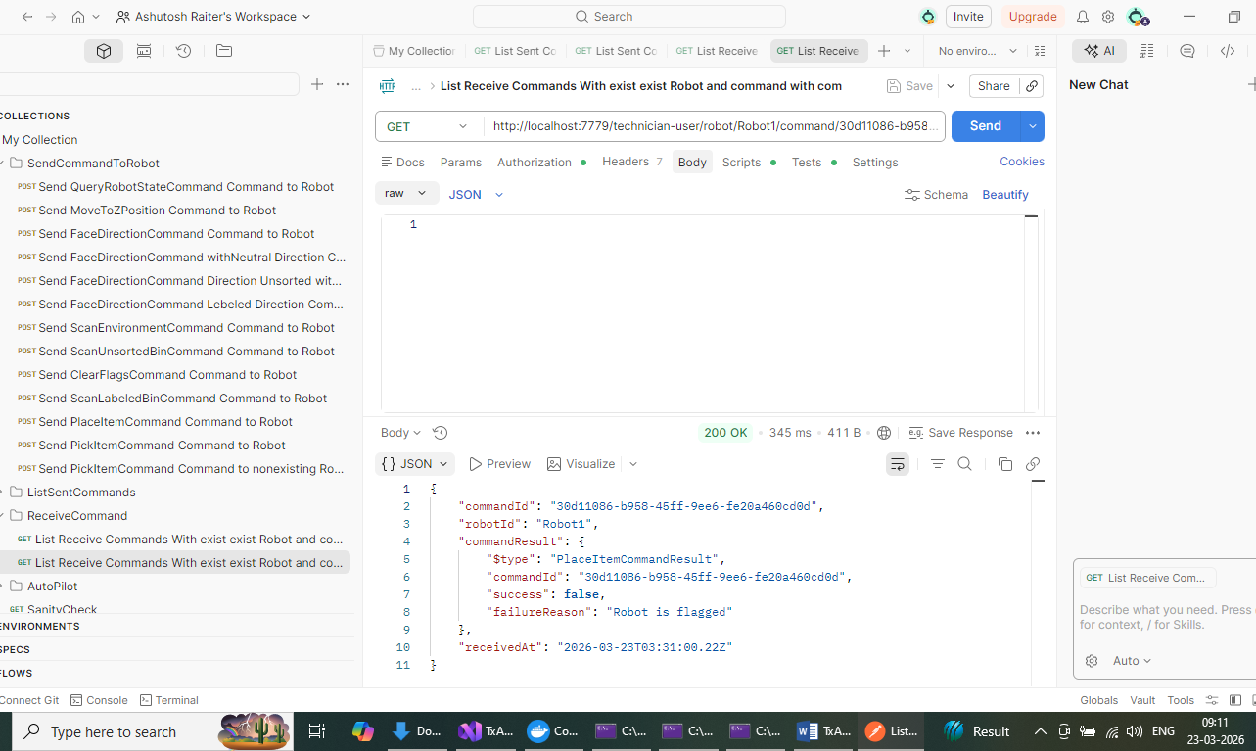
Now check Auto Pilot functionality
Exec -> CheckState before activatipon -> http://localhost:7779/technician-user/robot/Robot1/autopilot/state
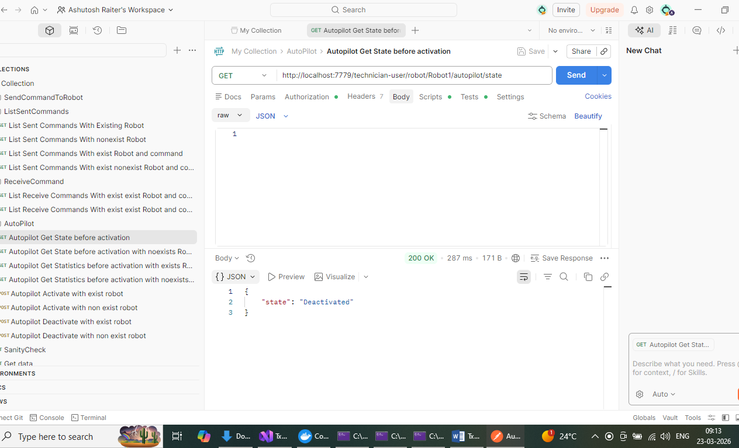
Now activate
Exec -> http://localhost:7779/technician-user/robot/Robot1/autopilot/activate
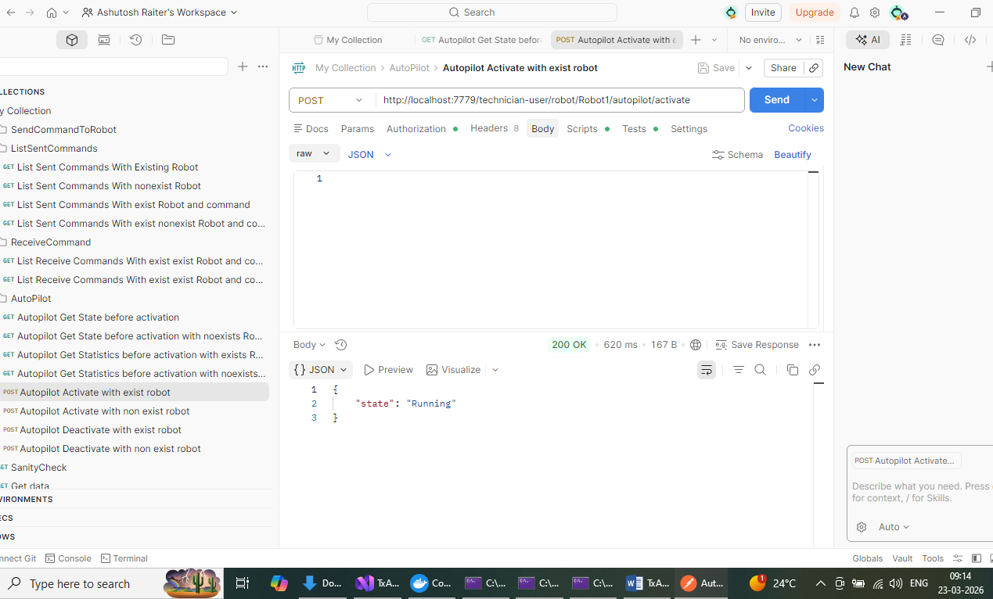
Its running
Robot Console – Autopilot started sending commands automatically
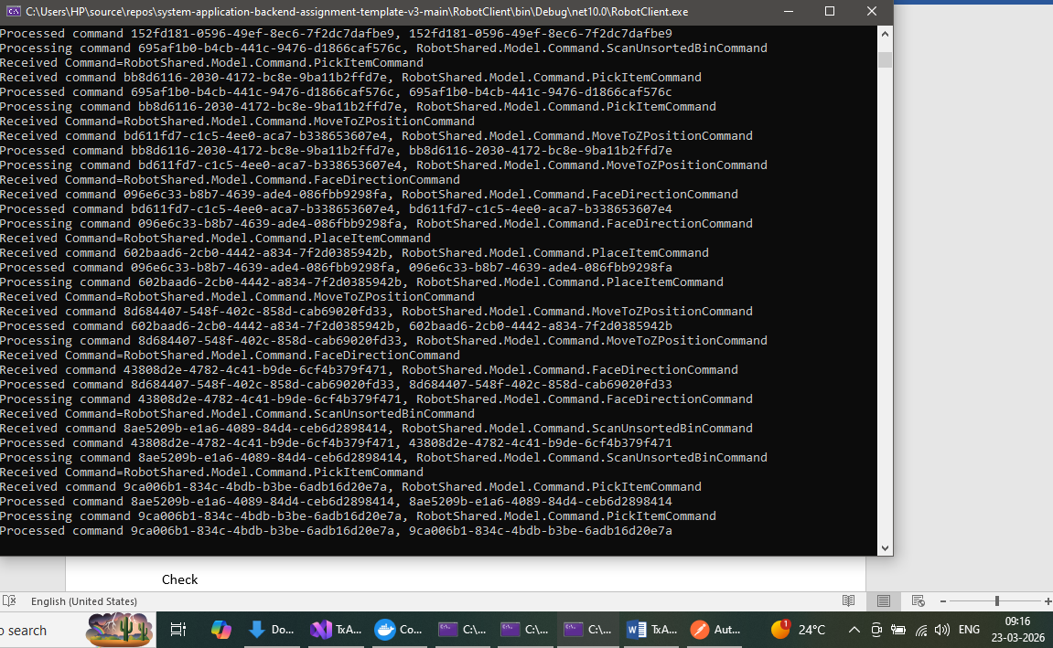
Check statistics
Exce http://localhost:7779/technician-user/robot/Robot1/autopilot/statistics
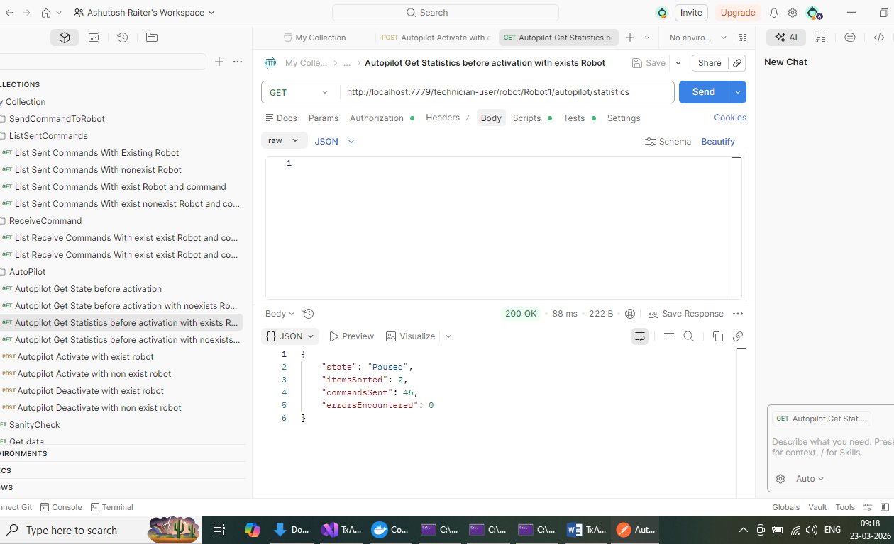

Numbers are increasing

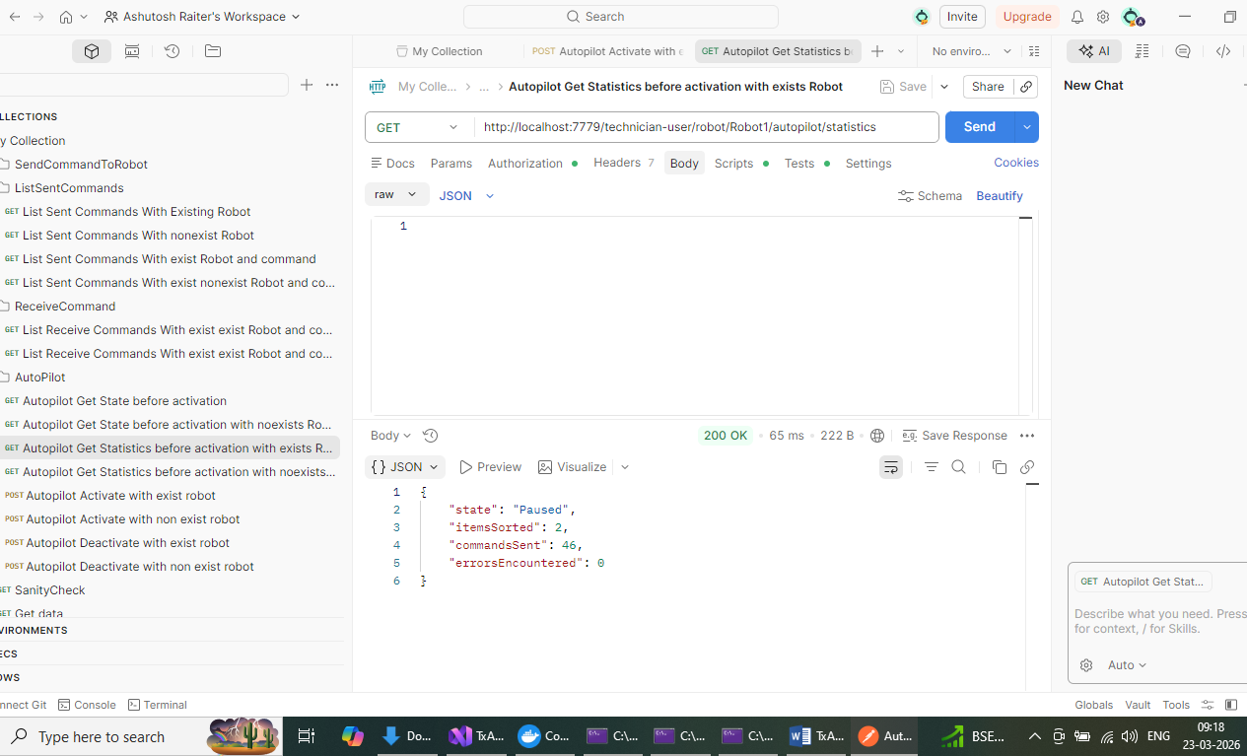

Autopilot deactivate
http://localhost:7779/technician-user/robot/Robot1/autopilot/deactivate
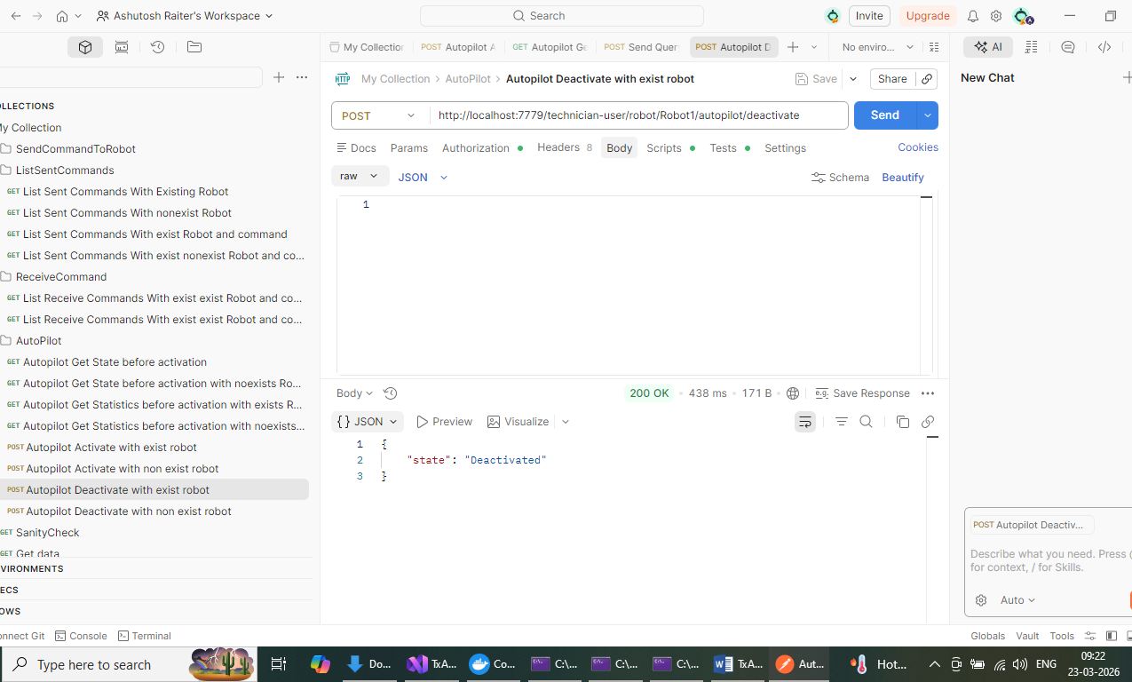
Exec -> http://localhost:7779/technician-user/robot/Robot1/command
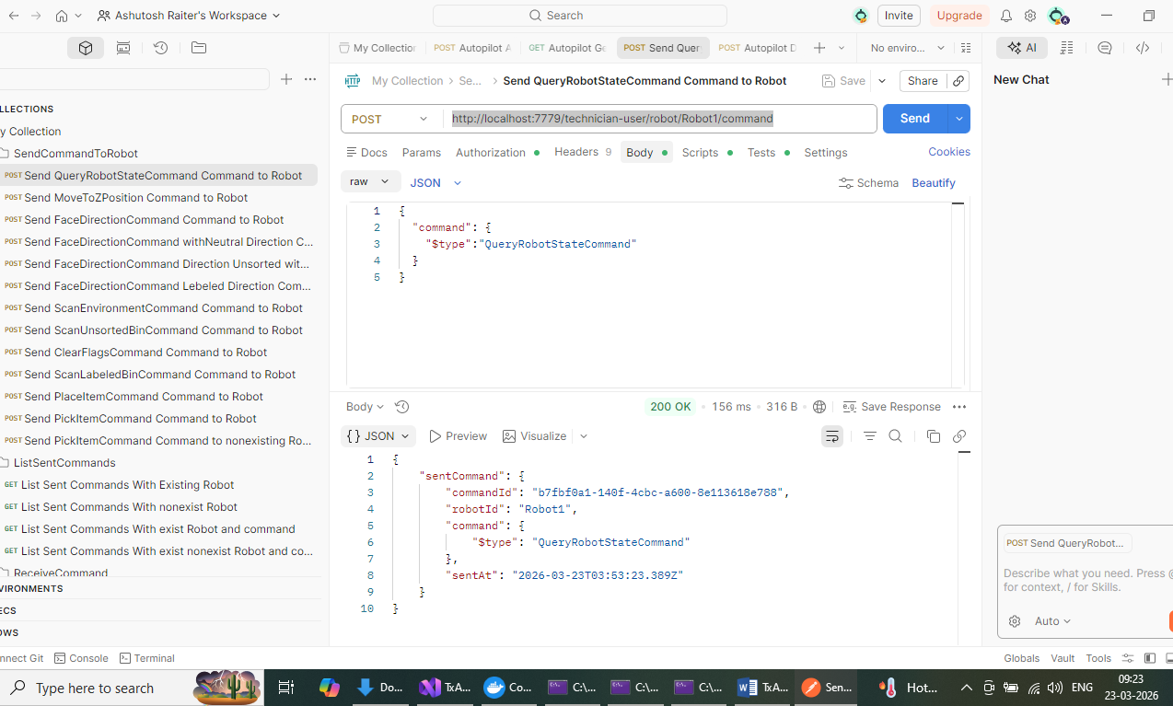

Clear Flagnow
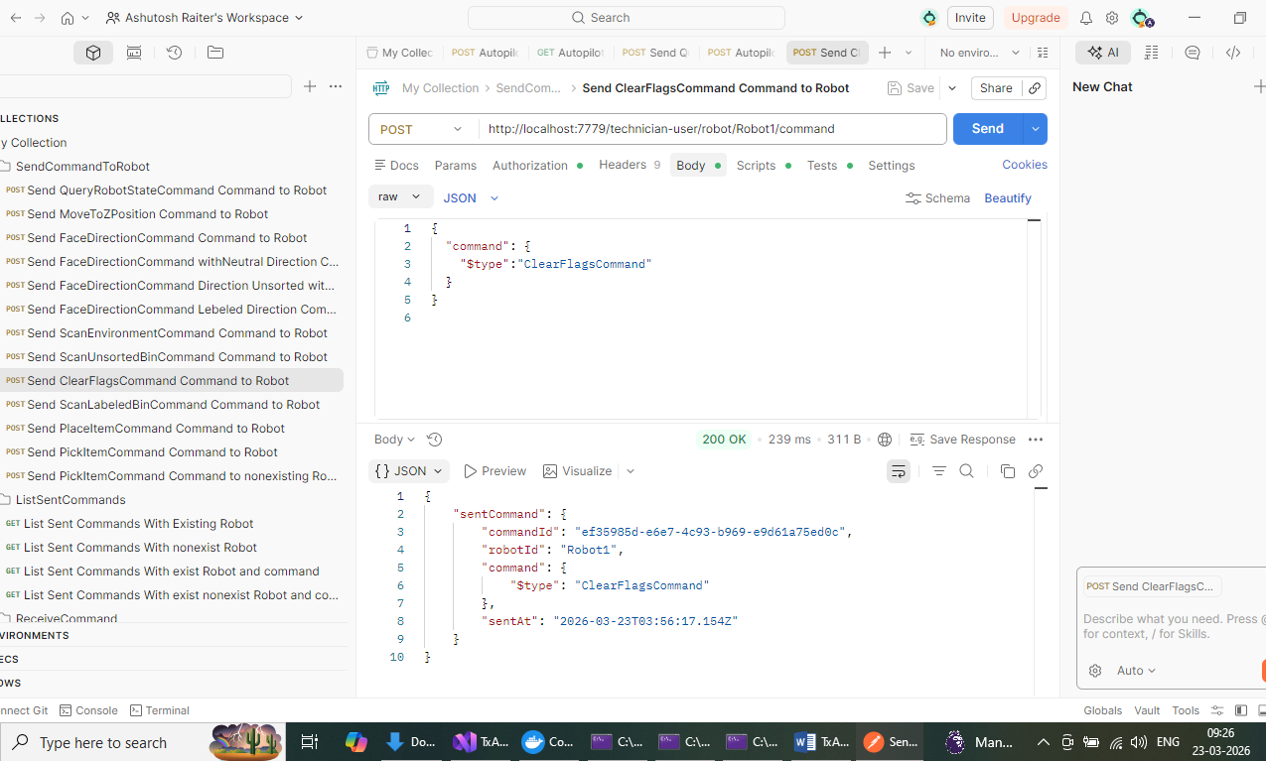
Check state
http://localhost:7779/technician-user/robot/Robot1/autopilot/state
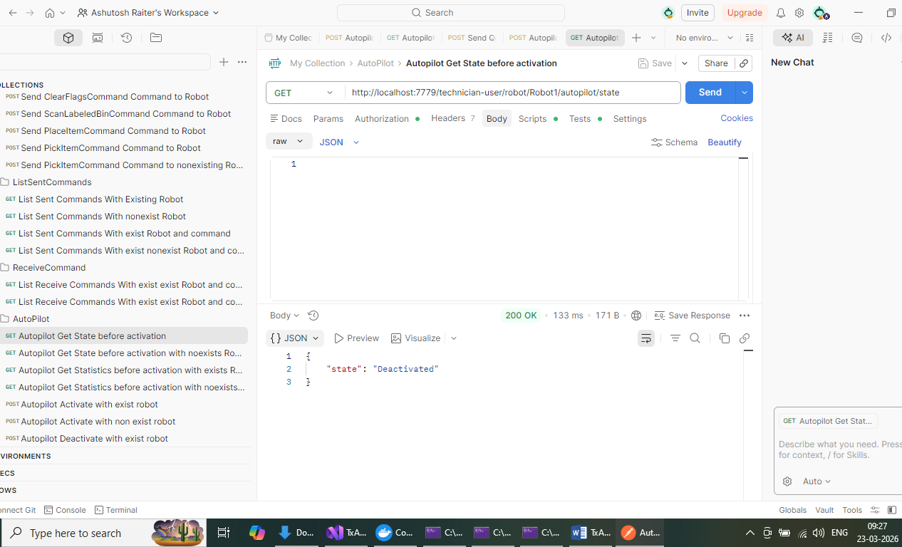

Scenario testing for Offline Robot
http://localhost:7779/technician-user/robot/Robot2/command Since robot2 is offline, returns 422
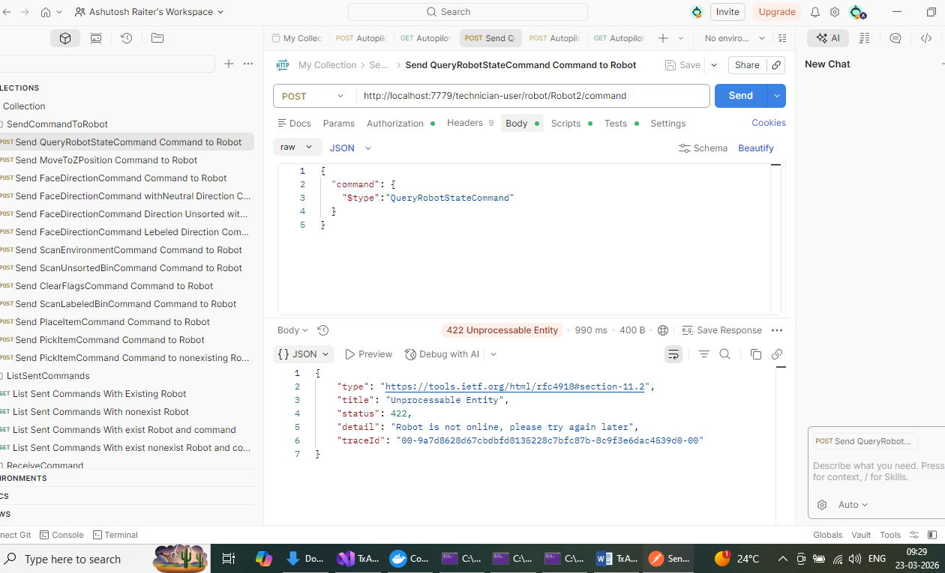
Auto pilot Activate for Robot 2
http://localhost:7779/technician-user/robot/Robot2/autopilot/activate Since robot2 is offline, returns 422

while auto-pilot mode is activated and running Any commands to control the robot sent by users must be ignored.
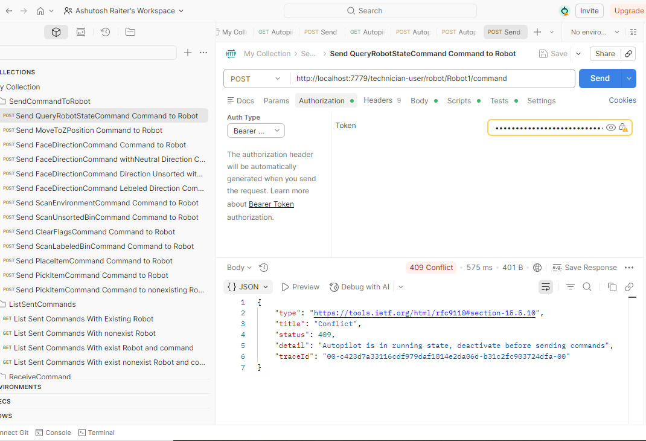

All test cases are working
Integration : 123
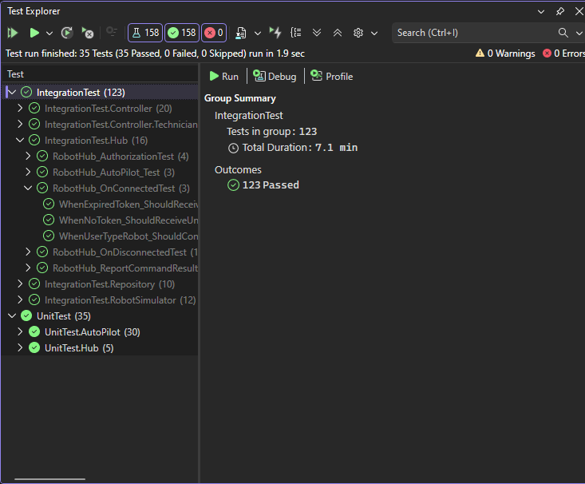
UnitTest : 35
